Dr. Burns
Operations Management
PRACTICE EXAM 2
YOUR NAME:
Multiple Choice _______________________________

Problems _______________________________

Total__________________________
Adjusted Total_______________________________

This exam consists of multiple choice and 3 discussion questions/problems. The multiple choice
questions are worth 50% of the exam grade. The problems are worth 50% of the exam grade. The exam is to be taken closed-book, closed-notes. Formulas are provided on the last page.

- There are three components to any software application. Which of the following is not one of the three.
- Presentation management
- Module management
- Business logic management
- Data management

2. In the list in 1 above, which resides in the server (assuming client/server architecture)?

3. in the list in 1 above, which resides either partially or completely in the client?

4. To add a module, like supply chain management, to the existing foray of modules that make up the ERP system, one must also add what:
a. another database engine
b. another module management engine
c. another client computer
d. nothing

5. Goldratt has proposed three phases to problem-solving. Which of the following is not one of the three?
a. What to change?
b. Why that is important?
c. What to change to?
d. How to cause the change?

6. The integrated group of business processes and activities that form the supply chain include all of the following except
- procurement of services, materials, and components from suppliers
- production of the products and services
- distribution of products to the customers
- information technology

7. Increased uncertainty and variability in a supply chain typically results in
- faster deliveries
- more accurate order fulfillment
- larger inventories
- lower costs

8. All of the following statements concerning inventory management are true except
a) In the past, companies could afford to maintain generous inventory levels and not worry so much about cost
b) the cost of inventory has increased largely due to product obsolescence
c) the average annual cost of manufactured goods inventory in the U.S. is about 30% of the value of the inventory
d) maximizing the amount of inventory has become an important objective of inventory management

9. Maintaining large inventories may be appropriate for all of the following reasons except
a) to meet seasonal peak demand
b) to take advantage of price discounts
c) to meet the demands of JIT companies
d) all of the statements above are appropriate reasons for large inventories

10. Inventory costs for such things as rent, lighting, security, interest, and taxes are usually classified as
a) carrying costs
b) ordering costs
c) shortage costs
d) continuous costs

11. Costs that are sometimes expressed as a percentage of the value of an item are known as
a) carrying costs
b) ordering costs
c) shortage costs
d) continuous costs

12. Inventory costs related to transportation, shipping, receiving, and inspection are usually classified as
a) carrying costs
b) ordering costs
c) continuous costs
d) holding costs

13. The continuous inventory control system
a) reviews shelf inventory by counting the number of items of inventory periodically
b) reduces the amount of inventory on record in the computer system every time a sale occurs
c) orders a different amount every time an order goes out.
d) none of the above
e) a and c only

14. In the ABC classification system,
a) A items are low value items that are sold frequently
b) B items are of moderate value, but sold very infrequently
c) C items are of low value and are sold infrequently

15. In the ABC classification system, which class consists of 50 to 60% of all inventory items accounts for 10% of the total dollar value of inventory?
a) A class
b) B class
c) C class

16. Which of the following is not an assumption of the basic EOQ model?
a) Demand is known with certainty.
b) Order quantity is received gradually over time.
c) Demand is relatively constant over time.
d) Lead time for receipt of orders is constant.

17. Which of the following statements concerning the basic EOQ model is true?
a) A decrease in demand will increase the EOQ value.
b) If an actual order quantity is smaller than the EOQ, the annual holding cost is less than the annual ordering cost.
c) An increase in holding cost will increase the EOQ value.
d) In the EOQ formula there is an inverse relationship between setup and carrying costs.

18. Warehouse management systems are
- highly automated systems that run the day-today- operations and track inventory at distribution centers
- systems for tracking inbound and outbound shipments and selecting carriers only
- systems that determine the optimal warehouse slotting for products only
- systems that control loading dock operation only

19. Optimizing the placement of items in a warehouse based on demand, product groupings, and the items’ physical characteristics is known as
- cross docking
- yard management
- slotting
- transportation management

20. A warehouse management system (WMS) might include all of the following features except
- transportation management
- human resource management
- order management
- warehouse optimization

21. Which of the following is not a typical effect of vendor managed inventory (VMI)?
- increased processing speed for manufacturers and distributors
- fewer data entry errors for manufacturers and distributors
- increased stockouts for distributors
- reduced planning and ordering costs for distributors

22. The most cost-effective means for transporting low-value, high density, bulk products is by
- trucks
- air
- railroads
- package delivery

23. Inventory turnover is computed
- by dividing the cost of goods sold by the average aggregate inventory value
- by dividing the average aggregate inventory value by costs of goods sold
- by multiplying the average aggregate inventory value by cost of goods sold
- subtracting cost of goods sold from the average aggregate inventory value

24. A company that produces small electric motors for treadmills had cost of goods sold last year of $241,000,000. The average value of inventory for raw materials, work-in-process, and finished goods are shown in the table below:

Raw Materials | $12,379,000
Work-In-Process | $7,631,000
Finished Goods | $9,275,000

Assuming the company operates 365 days a year the number of inventory turns would be
- 0.12
- 5.12
- 8.23
- 14.53

25. A company that produces printer cartridges had cost of goods sold last year of $629,462,423. The average value of inventory for raw materials, work-in-process, and finished goods are shown in the table below:

Raw Materials | $7,367,528
Work-In-Process | $22,893,232
Finished Goods | $16,523,451

If the company operates 50 weeks per year then the weeks of supply in inventory would be
- 3.716
- 2.493
- 13.4546
- 28.33

26. The fraction of orders filled by a distribution center or warehouse within a specific time period is referred to as the
- inventory turnover
- inventory supply time
- fill rate
- aggregate orders processed

27. Which of the following is a diagnostic tool that provides a cross-industry standard for supply chain management?
a. enterprise resource planning (ERP)
b. the supply chain operations reference (SCOR) model
c. warehouse management analysis
d. collaborative planning, forecasting and replenishment (CPFR)

28. In global trade the total cost of producing, storing, and transporting a product to the site of consumption or another port is referred to as the
- landed cost
- delivery cost
- value-added cost
- indirect cost

29. An indirect tax assessed on the increase in value of a good at any stage of the production process from raw material to final product is referred to as a
- landed cost
- tariff
- value-added tax
- duty

30. . Which of the following is not a strategy for managing demand?
a. shifting demand into other time periods with incentives, sales promotions and advertising campaigns
b. offering products or services with counter-cyclical demand patterns
c. partnering with suppliers to reduce information distortion along the supply chain
d. increasing inventories and laying off workers when demand is soft

31. For an EOQ model, calculate the optimal order quantity if the annual demand is 3000, the ordering cost is 50 and the carrying cost is 30.
a. 200
b. 300
c. 100
d. none of these

32. In problem 31 above, assume the number of days in which the facility is open for business is 300 and the lead time is ten days. What is the reorder point, not considering safety stock?
a. 10
b. 50
c. 100
d. 150
e. none of these

33. If the work-in-process is 100,000 wafers and the throughput is 5000 wafers per day, then the _______ ______ is _____ days.
a) cycle time, 20
b) run length, 20
c) cycle time, 40
d) run length, 40
e) none of these

34. In ABC classification, class ___ items constitute 5-15% of the items and 70-80% of the total dollar value to the firm
a) A b) B
c) C d) D
e) none of these

35. If a company places an order for the same quantity each time inventory decreases to a reorder point, it is using a
a) periodic inventory system
b) convoluted inventory system
c) continuous inventory system
d) discrete inventory system

36. Holding or carrying costs include all of the following except
a) transportation costs
b) rent of storage
c) interest costs
d) lighting
e) security

37. For a company that uses a periodic inventory system, which of the following is true?
a) inventory is counted only at specific time intervals
b) the order is for a fixed quantity which minimizes inventory costs
c) the inventory system is also referred to as a perpetual inventory system
d) the company is using a fixed-order-quantity system

38. Which of the following inventory systems gives you the highest holding cost?
a) continuous inventory systems
b) periodic review inventory systems
c) quantity discounts
d) instantaneous replenishment systems

39. Which of the following inventory systems utilizes a variable order quantity each time an order is submitted?
a) continuous inventory systems
b) periodic review inventory systems
c) quantity discounts
d) instantaneous replenishment systems

40. Which of the following statements is true?
a) In a fixed-order-quantity inventory system, a fixed quantity is ordered after a specific number of days, weeks, or months has passed.
b) In a periodic inventory system, a fixed quantity is ordered when inventory falls to the reorder point.
c) In a periodic inventory system, a new order quantity must be determined every time an order is made.
d) A continuous inventory system requires more safety stock than a periodic inventory system.

41. The information architecture underlying ERP systems is known as
a) mainframe
b) glasshouse
c) N-tier distributed
d) client/server
e) none of these

42. Carrying lots of safety stock is a bad thing because___
a. it increases the service level
b. it increases inventory and thus inventory cost
c. it increases the ordering cost
d. it increases the carrying cost
e. both c and d above

43. Which of the following is the best strategy for reducing safety stock?
a. reduce the standard deviation of daily demand
b. reduce the lead time
c. reduce the service level and thus the z value
d. all of the above

44. Modern corporate information infrastructures and systems utilize _____ on users desktops.
a) thin clients
b) thick clients
c) Internet browsers
d) none of these
e) a and c only

45. Today’s modern ERP architectures are intended to take advantage of
a) reusability
b) servers
c) thin clients
d) all of the above

46. Advantages of the N-tier architecture used in modern ERP systems includes all of the following but
a) data integration
b) better use of MIPS on both PCs and servers
c) elimination of the 36 month backlog of the centralized MIS shop
d) faster development times of new software because of reuse
e) diminished visibility across the enterprise

47. Which of the following statements concerning small lot production is true?
a) Small-lot production allows processes to be physically closer together.
b) Workers producing units in small lots tend to let poor quality pass.
c) Small lot production makes processes more independent of each other.
d) In small lot production, quality problems are more difficult to detect.

48. When new applications are built in an ERP environment what component invariably gets reused in its entirety?
a. module management
b. data management
c. presentation management
d. business logic management

49. Reuse of existing software in any new development context helps to
a. reduce development costs
b. shorten time to completion
c. improve quality
d. all of the above

50. The following transportation table shows the cost of shipping one unit from each source to each destination in the upper right hand corner of each cell, as well as the supply capacities and demand requirements:

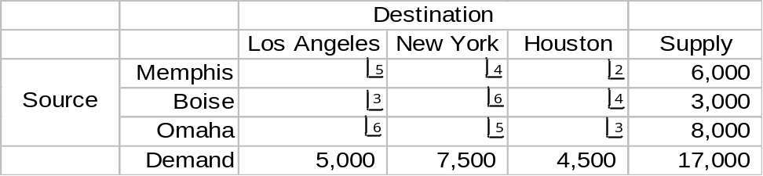

The optimal solution is:

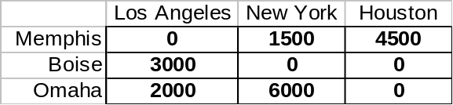

The total cost of the shipping plan is:
  - $17,000
  - $25,000
  - $50,000
  - $66,000

Problems/Exercises (50 points)

Problem 1 (20 points) Inventory involving independent demand
Southwest Airlines is trying to develop an inventory policy for maintaining its tires on its fleet of Boeing 737’s. Annual demand for tires runs 36,500 per year and the ordering cost is $1000.00 per order. The carrying cost is 30% of the purchase price and each tire costs $2000. Lead times on orders are three weeks and the company insists on a safety stock of 2000 tires. Since the company flies 365 days a year, assume every day is a business day.

(3) What is the optimal EOQ?

(3) What is the optimal total inventory cost?

(3) What is the reorder point, assuming 2000 tires in safety stock?

(3) How many orders go out in a year? What is the average time in days (assuming 365 days/yr) between orders?

(3) Suppose the standard deviation of daily demand on tires is 10 tires. In your opinion, is 2000 tires too much safety stock, if the company wants to be 99% certain it has sufficient tires on hand? Why or why not?

(5) Find the optimal order quantity if the supplier is willing to provide a discount for higher-volume purchases, as follows:
Minimum order quantity | Unit price
0-500 | 2000
501-1000 | 1800
1001+ | 1500

Problem 2 (14 points)

Fashion Apparel Direct (FAD) out-sources production of its line of women’s clothing to three major suppliers. The planning process at FAD consists of purchasing capacity at each supplier and submitting specific orders during the year to utilize the capacity. Costs and available capacity differ by supplier and time of year. Garments may be produced in advance of need, but the carrying cost is $1 per month. Use the demand and cost information given below to design a purchase plan for FAD. Monthly demand must be met, but capacity (supply) does not have to be entirely used.

Table 2
 |  | Supplier 1 | Suppl 1 | Supplier 2 | Suppl 2 | Supplier3 | Supp 3
Month | DEMAND | Capacity | Cost | Capacity | Cost | Capacity | Cost
September | 4000 | 1000 | 10 | 2000 | 11 | 1000 | 7
October | 3000 | 2000 | 8 | 1000 | 10 | 2000 | 8
November | 5000 | 2000 | 9 | 2000 | 8 | 1000 | 9
December | 6000 | 2000 | 10 | 1000 | 11 | 2000 | 10
(8 points)
 | Cost | Cost | Cost | Cost | Allocation | Allocation | Allocation | Allocation
 | Sept | Oct | Nov | Dec | Sept | Oct | Nov | Dec | Supply
sup 1 Sept |  |  |  |  |  |  |  |  | 1000
sup 2 Sept |  |  |  |  |  |  |  |  | 2000
sup 3 Sept |  |  |  |  |  |  |  |  | 1000
sup 1 Oct |  |  |  |  |  |  |  |  | 2000
sup 2 Oct |  |  |  |  |  |  |  |  | 1000
sup 3 Oct |  |  |  |  |  |  |  |  | 2000
sup 1 Nov |  |  |  |  |  |  |  |  | 2000
sup 2 Nov |  |  |  |  |  |  |  |  | 2000
sup 3 Nov |  |  |  |  |  |  |  |  | 1000
sup 1 Dec |  |  |  |  |  |  |  |  | 2000
sup 2 Dec |  |  |  |  |  |  |  |  | 1000
sup 3 Dec |  |  |  |  |  |  |  |  | 2000
Demand |  |  |  |  | 4000 | 3000 | 5000 | 6000 | 19,000

(4 points) What is the formula for (use actual numbers taken from the table above) as well as the total cost of your allocation plan?

(2 points) In words, explain what the allocation plan that you came up with is.
Problem 3 (16 points)
(4 points) Circa 1992, describe what was basically wrong with mainframe/glasshouse architecture.

(3 points) Draw the diagram representing mainframe/glass house architecture. For each application software package you include show and label its three components explicitly.

(3 points) Draw the diagram representing N-tier distributed information architecture. Describe what changed with respect to the three components that make up each application. Show where each component resides within the N-tier distributed architecture.

(2 points) Define what is meant by ERP. Discuss how the implementation of an ERP system should proceed.

(4 points) Discuss the advantages that ERP holds over mainframe/glasshouse architecture.

Problem 4 (14 points—extra credit)
The Household Robotic Company (HRC) produces a domestic robot at two plants on the east coast. These devices are shipped to two more centrally located warehouses. The costs to manufacture the unit at the plant are shown below for the months of October and November. Notice that manufacturing costs are expected to increase as a new labor contract goes into effect at the end of October.

PLANT  COSTS | OCTOBER | NOVEMBER
1 | 900 | 1000
2 | 800 | 900
It is possible to manufacture units during October and store them at the plants for November shipment, but not vice versa. Unit monthly storage costs are $30 at the plants. The capacities of each the plants are constant at 30,000 units per month per plant. The per unit cost of distributing the robots from the plant to warehouses A and B are shown below.

From/To | A | B
1 | $50 | $60
2 | $70 | $60

Demand for the robots is seasonal and varies at the distribution points A and B as shown below:

Month -------→  \\\\\\\\\\\\\\\\\\\\\\\\\  Warehouse | October | November
A | 20,000 | 30,000
B | 30,000 | 20,000

(8 points) Formulate a transportation matrix for this problem. (Decide what your sources of supply are—set aside a row for each source, placing the capacity of that source at the end of the row. Decide what your individual demands are and create a column for each such demand.) How many decision cells are there? How many constraints are there?
(6 points) Does this model have a feasible solution? Why? Find a near optimal solution to this model just by using the simple heuristic we illustrated in class. Examine each row for the minimum cost in that row and allocate the smaller of the associated supply and demand numbers to the minimum cost cell in that row. Calculate the overall cost for your production/transportation/storage schedule.

Answers to Practice Exam II

1) b
2) d
3) a
4) b
5) b
6) d
7) c
8) d
9) d
10) a
11) a
12) b
13) b
14) c
15) c
16) b
17) b
18) a
19) c
20) b
21) c
22) c
23) a
24) c
25) a
26) c
27) b
28) a
29) c
30) d
31) c
32) c
33) a
34) a
35) c
36) a
37) a
38) c
39) b
40) c
41) c
42) b
43) b
44) e
45) d
46) e
47) a
48) b
49) d
50) d

Problem 1 (20 points) Inventory involving independent demand
Southwest Airlines is trying to develop an inventory policy for maintaining its tires on its fleet of Boeing 737’s. Annual demand for tires runs 36,500 per year and the ordering cost is $1000.00 per order. The carrying cost is 30% of the purchase price and each tire costs $2000. Lead times on orders are three weeks and the company insists on a safety stock of 2000 tires. Since the company flies 365 days a year, assume every day is a business day.

(3) What is the optimal EOQ? EOQ*=348.8

(3) What is the optimal total inventory cost? TC* = $209,284.50

(3) What is the reorder point, assuming 2000 tires in safety stock? R = 4100

(3) How many orders go out in a year? What is the average time in days (assuming 365 days/yr) between orders?
Orders = D/EOQ* = 104.64

(3) Suppose the standard deviation of daily demand on tires is 10 tires. In your opinion, is 2000 tires too much safety stock, if the company wants to be 99% certain it has sufficient tires on hand? Why or why not?
Yes, 2000 tires is way too much safety stock. The safety stock formula (=3*10*sqrt(L)) calls for only 137.5 tires.

(5) Find the optimal order quantity if the supplier is willing to provide a discount for higher-volume purchases, as follows:
Minimum order quantity | Unit price
0-500 | 2000
501-1000 | 1800
1001+ | 1500

TC(EOQ*) = $73,209,284
TC(501) = $65,923,154
TC(1001) = $55,086,764 ← The best choice -- order in quantities of 1001

Problem 2 (14 points)

Fashion Apparel Direct (FAD) out-sources production of its line of women’s clothing to three major suppliers. The planning process at FAD consists of purchasing capacity at each supplier and submitting specific orders during the year to utilize the capacity. Costs and available capacity differ by supplier and time of year. Garments may be produced in advance of need, but the carrying cost is $1 per month. Use the demand and cost information given below to design a purchase plan for FAD. Monthly demand must be met, but capacity (supply) does not have to be entirely used.

Table 2
 |  | Supplier 1 | Suppl 1 | Supplier 2 | Suppl 2 | Supplier3 | Supp 3
Month | DEMAND | Capacity | Cost | Capacity | Cost | Capacity | Cost
September | 4000 | 1000 | 10 | 2000 | 11 | 1000 | 7
October | 3000 | 2000 | 8 | 1000 | 10 | 2000 | 8
November | 5000 | 2000 | 9 | 2000 | 8 | 1000 | 9
December | 6000 | 2000 | 10 | 1000 | 11 | 2000 | 10
(8 points)
 | Cost | Cost | Cost | Cost | Allocation | Allocation | Allocation | Allocation
 | Sept | Oct | Nov | Dec | Sept | Oct | Nov | Dec | Supply
sup 1 Sept | 10 | 11 | 12 | 13 | 1000 |  |  |  | 1000
sup 2 Sept | 11 | 12 | 13 | 14 | 2000 |  |  |  | 2000
sup 3 Sept | 7 | 8 | 9 | 10 | 1000 |  |  |  | 1000
sup 1 Oct | 1000 | 8 | 9 | 10 |  | 2000 |  |  | 2000
sup 2 Oct | 1000 | 10 | 11 | 12 |  | 1000 |  |  | 1000
sup 3 Oct | 1000 | 8 | 9 | 10 |  |  | 2000 |  | 2000
sup 1 Nov | 1000 | 1000 | 9 | 10 |  |  | 2000 |  | 2000
sup 2 Nov | 1000 | 1000 | 8 | 9 |  |  | 1000 | 1000 | 2000
sup 3 Nov | 1000 | 1000 | 9 | 10 |  |  |  | 1000 | 1000
sup 1 Dec | 1000 | 1000 | 1000 | 10 |  |  |  | 2000 | 2000
sup 2 Dec | 1000 | 1000 | 1000 | 11 |  |  |  | 1000 | 1000
sup 3 Dec | 1000 | 1000 | 1000 | 10 |  |  |  | 1000 | 2000
Demand |  |  |  |  | 4000 | 3000 | 5000 | 6000 | 19,000

(4 points) What is the formula for (use actual numbers taken from the table above) as well as the total cost of your allocation plan?
=1000*10+2000*11+1000*7+2000*8+1000*10+2000*9+2000*9+1000*8+1000*9+1000*10+2000*10+1000*11+1000*10
=10,000+22,000+7000+16,000+10,000+18,000+18,000+8,000+9000+10,000+20,000+11,000+10,000
=169,000

Notice in this problem that there is an excess of supply over demand by 1000 units.

(2 points) In words, explain what the allocation plan that you came up with is.
1000 units of supply from supplier 1’s Sept supply gets allocated to meet Sept demand
2000 units of supply from supplier 2’s Sept supply gets allocated to meet Sept demand
1000 units of supply from supplier 3’s Sept supply gets allocated to meet Sept demand
Etc.
Problem 3 (16 points)
(4 points) Circa 1992, describe what was basically wrong with mainframe/glasshouse architecture.
1) No visibility across departments and suppliers
2) thirty-six month backlog on modifications to existing software applications
3) long, expensive development times for new applications
4) mainframes were computational bottlenecks
5) no GUI interface
6) reusability not possible
(3 points) Draw the diagram representing mainframe/glass house architecture. For each application software package you include show and label its three components explicitly.

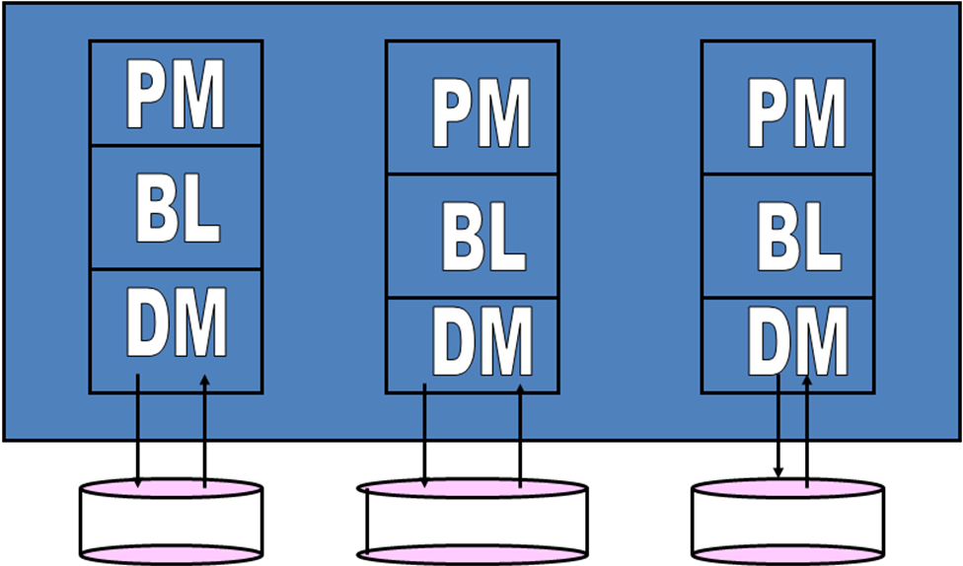

(3 points) Draw the diagram representing N-tier distributed information architecture. Describe what changed with respect to the three components that make up each application. Show where each component resides within the N-tier distributed architecture.

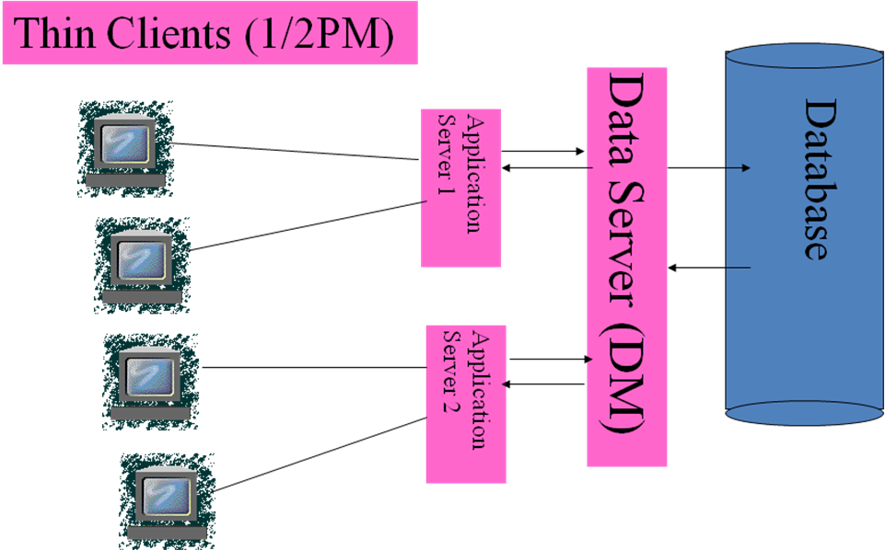

Half of the presentation management resides on the client (the Internet browser). The other half of the presentation management resides on the application (the part that serves out web pages), as well as the business logic. Finally, the data management resides on the data server.

(2 points) Discuss the opportunities for re-use that exist within the N-tier distributed architecture. Did these opportunities exist within the mainframe/glasshouse architecture?
Can re-use all of the Data Management component
Can re-use the Internet browser portion of the Presentation Management component
Occasionally it occurs that portions of the application server components can be re-used.
None of these opportunities existed within the mainframe/glasshouse architecture.

(2 points) Define what is meant by ERP. Discuss how the implementation of an ERP system should proceed.
ERP is Enterprise Resource Planning, an outgrowth of MRP, which got its start in the 1970’s. It is the backbone of corporate computing today. Implementation of an ERP system should start with an identification of processes and with which of these are badly in need of revision/innovation.

(4 points) Discuss the advantages that ERP holds over mainframe/glasshouse architecture.
ERP uses an N-tier information architecture and overcomes all of the problems mentioned in the first question above. So ERP creates visibility, eliminates 36 mo. Backlogs, reduces development times and costs, and eliminates the mainframe as an expensive computational bottleneck. In addition, ERP allows for the use of COTS, which is much cheaper than building from scratch, and permits best-of-breed choices. In short, Enterprise visibility; enterprise integration; quicker, cheaper new application development; elimination of 36 month backlogs in the centralized MIS shop; better career management for the IT professional; better management of software modules are all advantages.

Problem 4 (14 points)
The Household Robotic Company (HRC) produces a domestic robot at one plant on the east coast. These devices are shipped to two more centrally located warehouses. The costs to manufacture the unit at the plant are shown below for the months of October and November. Notice that manufacturing costs are expected to increase as a new labor contract goes into effect at the end of October.

PLANT  COSTS | OCTOBER | NOVEMBER
1 | 900 | 1000
2 | 800 | 900
It is possible to manufacture units during October and store them at the plant for November shipment, but not vice versa. Unit monthly storage costs are $30 at the plant. The capacities of each plant are constant at 30,000 units per month. The per unit cost of distributing the robots from the plant to warehouses A and B are shown below.
From/To | A | B
1 | $50 | $60
2 | $70 | $60
Demand for the robots is seasonal and varies at the distribution points A and B as shown below:
Month -------→  \\\\\\\\\\\\\\\\\\\\\\\\\  Warehouse | October | November
A | 20,000 | 30,000
B | 30,000 | 20,000
(6 points) Formulate a transportation matrix for this problem. (Decide what your sources of supply are—set aside a row for each source, placing the capacity of that source at the end of the row. Decide what your individual demands are and create a column for each such demand.)
(8 points) Does this model have a feasible solution? Why? Find a near optimal solution to this model just by using the simple heuristic we illustrated in class (the row minimum method).
 |  | Oct A Dem | Oct B Dem | Nov A Dem | Nov B Dem | SUPPLY
Plant 1 October Prod |  | $950 | $960 | $980 | $990 | 30,000
Plant 1 November Prod |  | $10,000 | $10,000 | $1,050 | $1,060 | 30,000
Plant 2 Oct Pr |  | $870 | $860 | $900 | $890 | 30,000
Plant 2 Nov P |  | $10,000 | $10,000 | $970 | $960 | 30,000
 | DEMAND | 20,000 | 30,000 | 30,000 | 20,000
____________ | ________ | _______ | _______ | _______ | _______ | _______
 |  | Oct A Dem | Oct B Dem | Nov A Dem | Nov B Dem | SUPPLY
Plant 1 October Prod |  | 20,000 | 10,000 |  |  | 30,000
Plant 2 November Prod |  |  |  | 30,000 |  | 30,000
Plant 2 Oct Pr |  |  | 20,000 |  | 10,000 | 30,000
Plant 2 Nov P |  |  |  |  | 10,000 | 30,000
 | DEMAND | 20,000 | 30,000 | 30,000 | 20,000
Yes, this model does have a feasible solution
Total cost of this solution is $95,800,000

Enterprise Resource Planning
Enterprise Resource Planning

